1. Action Plan
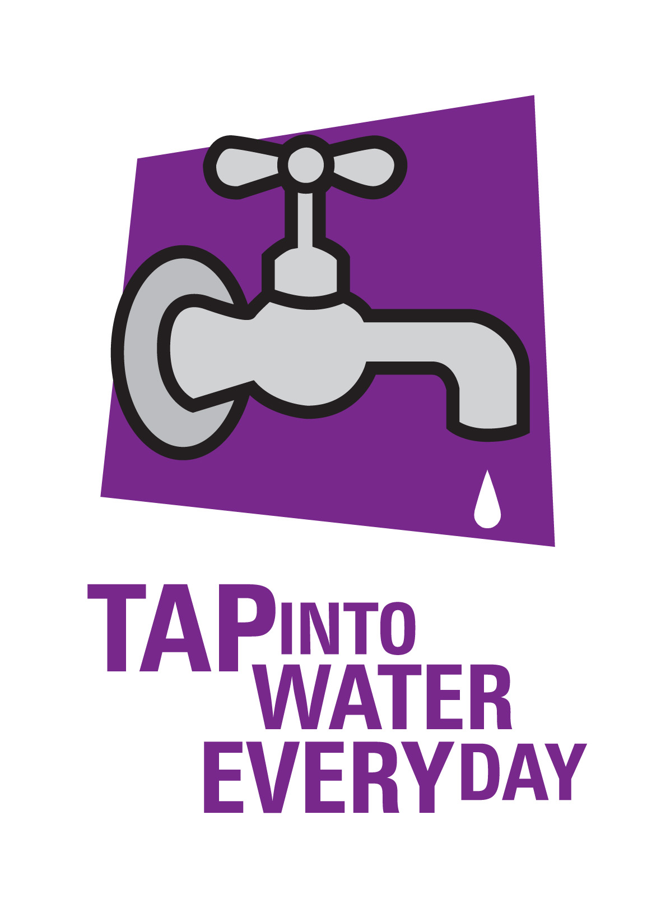

Tap into water every day
- instead of sweet drinks

Criteria 1 The school has a strategy in place to encourage all students to drink water throughout the school day, especially during physical activity. Only water is permitted for drinking in class time.

Why this criterion is important
This criterion aims to promote healthy drink choices by making access to drinking water easy and by removing competing sweet drinks from the classroom. Tap water and plain reduced fat milk are the best drink choices and are ideally enjoyed everyday at school.

To Do List
Use the following table to help plan what actions need to be taken to meet the criterion. Add more pages if you need them.

What  What action needs to be taken? (eg water bottles purchased, school community information, policy development) | How  How will it be done? (eg water display, tip sheets for parents, resources, meetings, newsletters inserts) | Who  Who will be responsible for organising the action? | When  When is it to be completed?

This is a Healthy Tasmania initiative
2017

