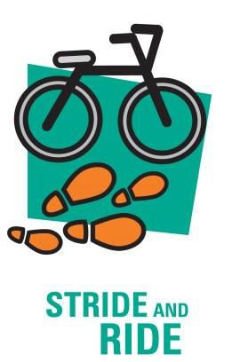
Pedometer Challenges

Quick Challenges

Wear a pedometer for these activities.
Do these challenges and record the number of steps shown on the pedometer.

Challenges | Number on the pedometer
Take 50 small steps
Take 50 large steps
Take 50 slow steps
Take 50 running steps
How many steps can you accumulate in 30 seconds?
How far can you travel without the pedometer recording any steps?
Take 50 small steps
Add your own below

Did your pedometer show more steps when taking small or large steps?

What was your favourite challenge and why?

Guess the Steps

Estimate the number of steps it will take for these walks around your school grounds.

Test and compare your result with your estimate.

Path to Take | Estimate Number of Steps | Actual Number of Steps
Walk to the office and back to the classroom
Walk around the widest boundary on the oval
Walk to the canteen and back to the classroom
Add your own below

Were your estimates close?

Did you usually overestimate or underestimate?

These Pedometer Challenges have been adapted from Goulburn Street Primary School. For more active travel information visit the Move Well Eat Well Stride and Ride page. Remember to have your school’s login details ready.

http://movewelleatwell.tas.gov.au/primary_schools/stride_and_ride

