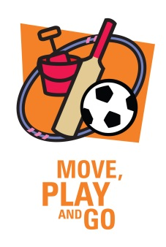

Move Play and Go Action Plan

Criteria 4 The timetabling of physical education, physical activity and sport is consistent with the UNESCO guidelines for Policy Makers.

Why is this criterion important?

Meeting physical education, physical activity and sport requirements is one of the most important ways schools can have a positive and direct impact on every student’s health and wellbeing. Meeting this criterion supports children’s health and wellbeing in two key ways:

- Physical education and sport which supports the development of students’ motor skills, movement competence and health-related physical fitness to promote lifelong participation in physical activity.
2. This criterion helps students meet daily physical activity guidelines and provides opportunities for participation in regular physical activity.
Refer to the Starter Pack glossary for definitions of physical activity and ‘Australia’s physical activity recommendations for children aged 5–12 years’.

To Do List
Complete the following table to help plan what actions need to be taken to meet the criteria. Add more pages if you need them.

What  What action needs to be taken? eg review of timetable, staff professional development, increase PE staff allocation, program design) | How  How will it be done? (eg look at Daily Fitness page on MWEW website for ideas, HPE teacher to help support other staff ) | Who  Who will be responsible for organising the action? | When  When is it to be completed?
This is a Healthy Tasmania initiative 2020

