Eating Well
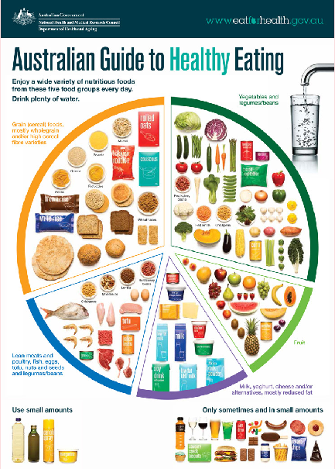

Food and drink guidelines
The guidelines recommend that we:
- Eat mostly food from the five food groups (these are the foods that sit on the healthy eating plate) Try to choose mono or polyunsaturated oils in your cooking, including olive and canola oil. Choose these in preference to saturated fats such as butter.
- Eat foods that aren’t in the five food groups sometimes or in small amounts. These foods sit to the bottom right of the plate. Eat foods that aren’t in the five food groups sometimes or in small amounts.
- Keep hydrated by drinking between six to eight glasses of fluid a day. Choose water as your main drink.
- For children and young people under 18 years of age, not drinking alcohol is the safest option. If you do drink alcohol – limit your intake.

Mindful eating
To eat well, it is also important to think about how and why you are eating. This can influence the amount and type of food you choose to eat. Mindful eating is when you use all your senses to notice the look, smell, taste, and sound of your food and how you feel physically and emotionally. Being mindful can make eating more enjoyable and satisfying.
Here are some tips for eating mindfully:
- Try to sit down at a table when you are eating. Turn off distractions including your phone, tablet or television.
- Eat regularly and mostly when you are hungry. If you have lost touch with when you are hungry, practice mindfulness to tune into your personal signals of hunger. Some signs of hunger are a dry throat or rumbling in the stomach.
- Try to avoid eating because you are feeling bored, sad or stressed (or any other emotion). Look for activities that will help with those emotions, such as talking to a friend, going for a walk or writing in a journal.

Eating with others
To eat well, try to eat with friends and family as often as possible. Eating with others can benefit your physical, social and mental health. People who eat together tend to eat more everyday foods and less sometimes foods. To get the most benefit out of eating with others, it is best to avoid screen time during meals.

